**EXAMPLE CLASS REPORT**

**CE1002 INTRODUCTION TO COMPUTING SYSTEMS**

**LAB GROUP FE2:**

**EDWIN CANDINEGARA / U1320135K**

**HU SIYU / U1321469A**

**JAYAKUMAR SANJANA / U1322888L**

**SEMESTER 1**

**AY 2013/2014**

**SCHOOL OF COMPUTER ENGINEERING**

**NANYANG TECHNOLOGICAL UNIVERSITY**

1. **Introduction**

This website has been created as a part of our project in CE1002 Introduction in Computing Systems in order to enhance our knowledge in HTML, PHP, and database. This website is an online book store called “The Book Shelf”. In this website, we are able to register a new user, log in as user, buy books online, manipulate orders, and other things. Furthermore, we also use JavaScript for simple form validation in this project.

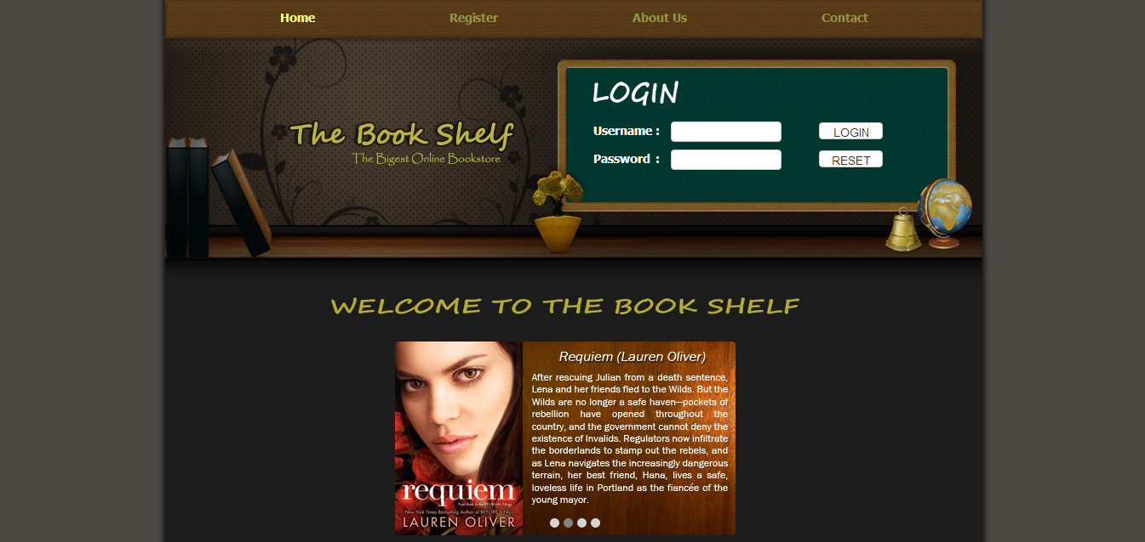

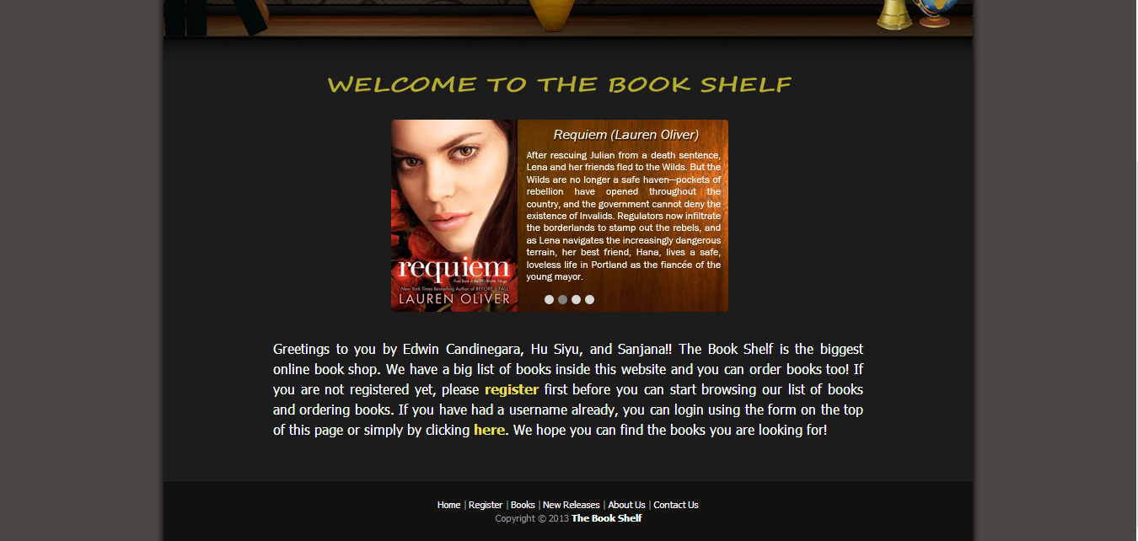

1. **Database**

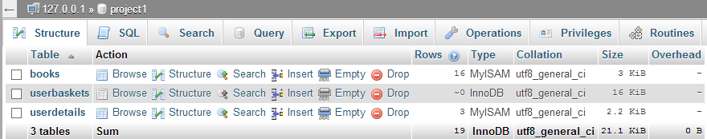The database “project1” has three tables which are books, userdetails, and userbaskets. We use these three tables to store all information related to the user’s details, user’s orders, and book’s details.

**2.1 Books**

The books table has six fields. They are bookid, type, bookname, author, quantity, and price. The bookid field is the primary key of this table. Each book has its own book ID. This table stores all information related to the books which are put in the website.

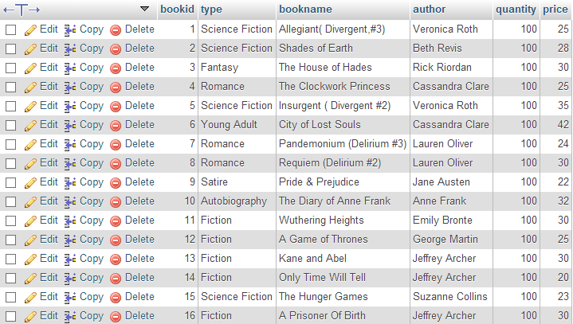

**2.2 Userbaskets**

The userbaskets table consists of eight fields. They are buyid, username, bookid, bookname, author, type, quantity, and totalprice. The buyid and username fields are the primary keys in this table. The username connects this table with userdetails table and the buyid, which increments automatically, is to distinguish between one orders with another. Basically, this table stores every order details.



**2.3 Userdetails**

The third table is the userdetails table. It has nine fields which are username, password, type, firstname, lastname, phone, email, address, and lasttime. The unique field is the username. In addition, the username and password fields are using utf8_bin collation so that the username and password are case sensitive.



1. **WEBSITE**

**3.1 Login Page**

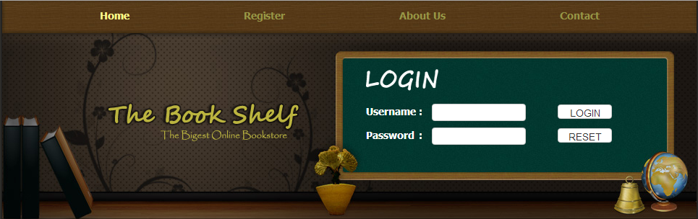

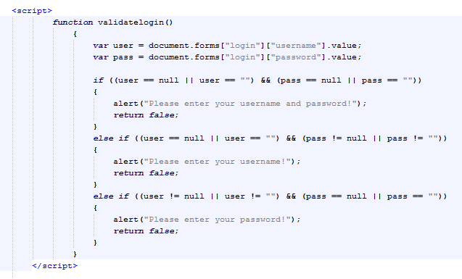The login form can be found on the homepage. This form is processed by login.php and also validated first by a JavaScript function as in the picture below.

As long as one of the two textboxes are empty, the JavaScript function will provide an alert message and the form will not be processed by login.php.

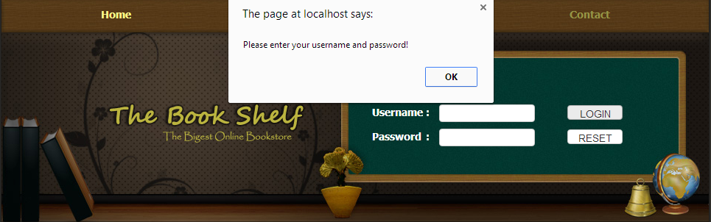

After the textboxes are filled in, login.php will process the data by checking whether the username exists or not and the user’s type. If the login process is successful, and its type is normal user, the user will be directed to basket.php. If the user’s type is admin, then the admin user will be brought to the adminusers.php page. Moreover, the username and password will be saved as $_SESSION variables so that it is reusable in other pages.

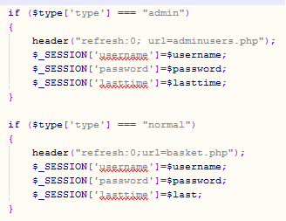

On the other hand, if it does not exist, the PHP file will run a script alerting the user and redirect the user to the registration page.

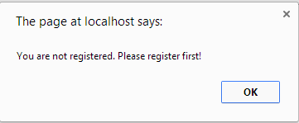

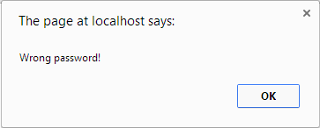In addition, if the username exists, but the user inserts a wrong password, the PHP file will tell the user that his/her password is wrong.

**3.2** **Registration Page**

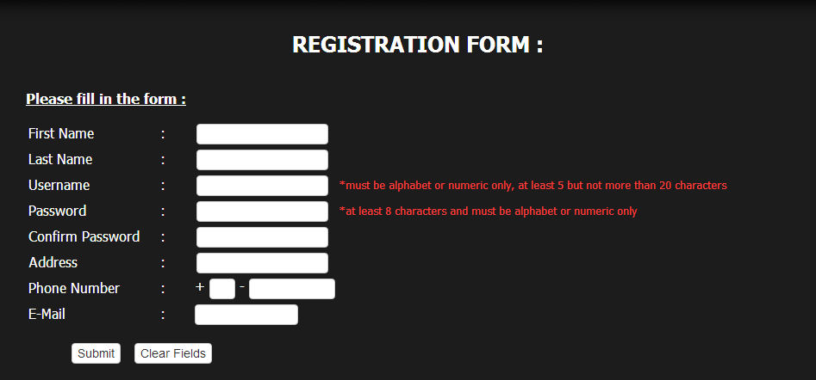

Basically, this page provides form used for registering a new user. As in login form, this form is also validated using JavaScript first. An alert box is popped if a condition is not fulfilled. For example, a textbox is blank, the first name and last name contain a number, and other validations.

Once the submit button is pressed, the data is processed by registration.php. It checks whether the username has existed before. If the username does not exist, the PHP file will update userdetails table with the data. Otherwise, the PHP file will bring you back to the registration page.

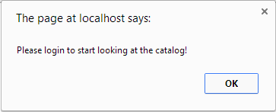When the registration process is successful, the PHP will pop an alert message telling the new user to login first and redirect him/her to the home page.

**3.3 Logging In**

**Normal User:**

When you log in as a normal user, you will be directed to the basket.php page where you can see your book orders. After you log in, you will be able to see your status such as how many orders you have, your last login time, and also it provides a link which brings you to a page where you can change your password.



**“Your Basket” Page:**

In basket.php, user can alter their book orders. They can change the quantity of the books and delete their orders by using their buy ID specified in the order’s table. Inside the basket.php, we use PHP while loops to show the content of the order’s table. Further, deleting order is done by the deletebook.php and changing quantity is done by using changeqty.php file.

To delete book orders:

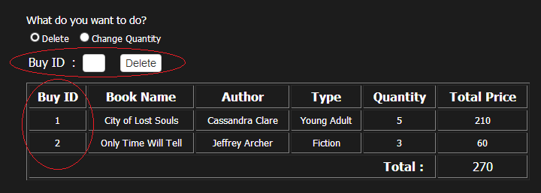

Use while loop in PHP

To change the quantity of books ordered:

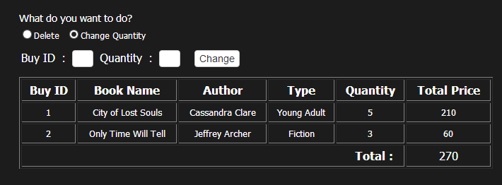

**Admin user:**

If you are an admin, you will be directed to adminusers.php page after logging in successfully. Admin has the power to delete users, and orders, and to see the full details of each books available.

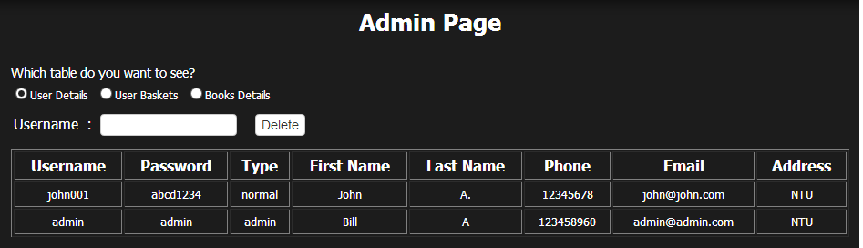

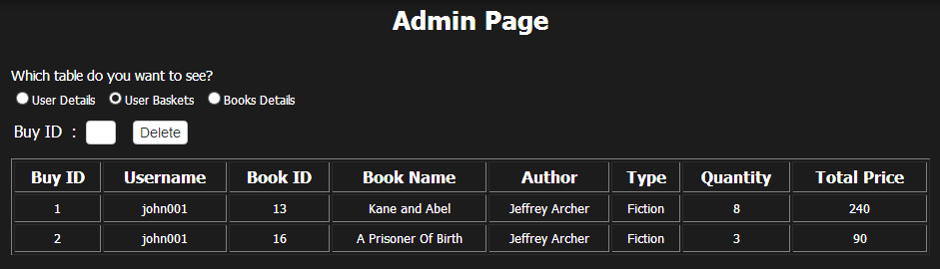

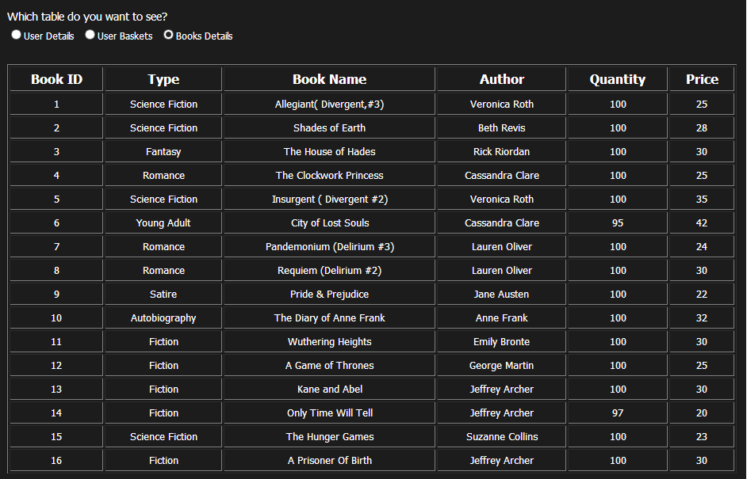

The deleting username process is done by the deleteuser.php file while the deleting orders process is done by the deletebookadmin.php.

**3.4 Logging Out:**

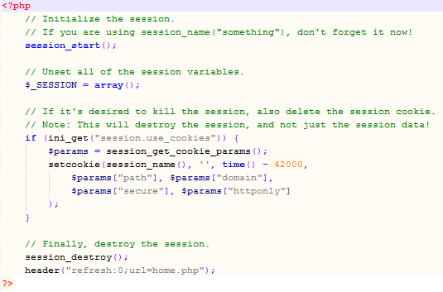User can easily log out from the system by clicking the “Logout” button which is in the status board on the top of the page. When a user logs out, the logout.php file will destroy the session, unset all session variables, and also delete session cookies.

**3.6 Changing Password**

User is able to change their password after the user is logged in. Changing password can be done by clicking the link found in the status board. It will bring the user to change_pass.php where a form to change password can be found. This form will be processed using changepassword.php. It will update the user’s password in the userdetails table inside the database.

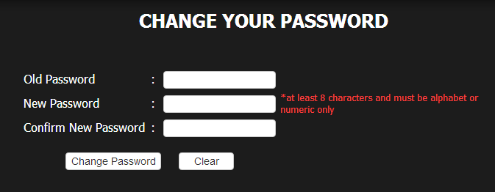

**3.6 Books**

In this page, the user can view books of different genres and their prices. Further, user can read the full description of a book by simply clicking the “Read more…” button. Clicking the button will bring the user to a particular book page where user can also find a form used for adding an order.

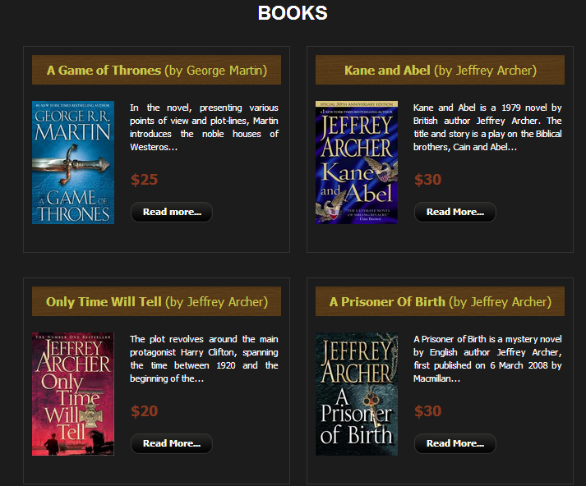

**3.7 Ordering a book:**

There are 16 book’s description pages. Each pages has a synopsis or a short description of the book, a form which is used by user to add a book order, and also it shows the number of books available in the store. Once a user adds an order, the table inside the database will be updated. This process is be done by bookadd.php.

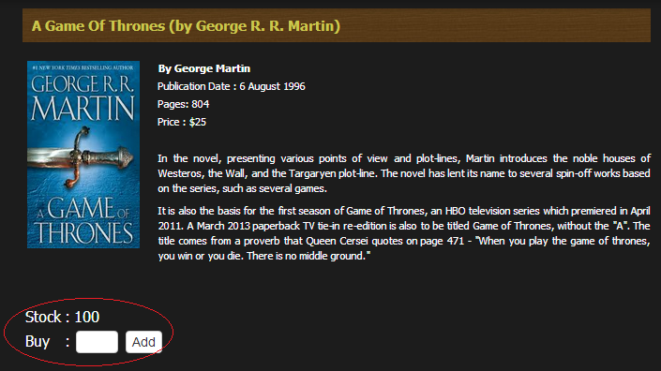

**3.8 Contact Us**

In fact, there are two Contact Us page in this website. The first one, “contact1.php”, is used by any person in general, who enters the website, can leave an enquiry on this page. It does not contain attributes like Categories or Bestseller, and contains tabs like Home, Register, About Us and Contact on the top of the page. This contact form will then be processed by emailsend1.php.

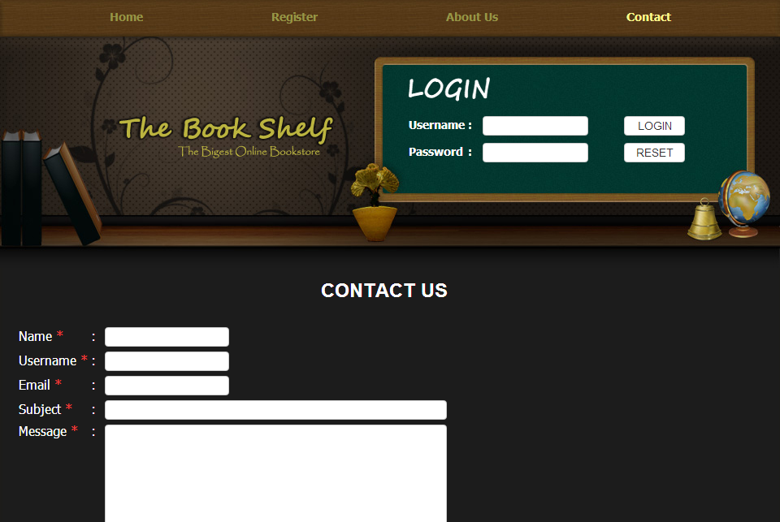

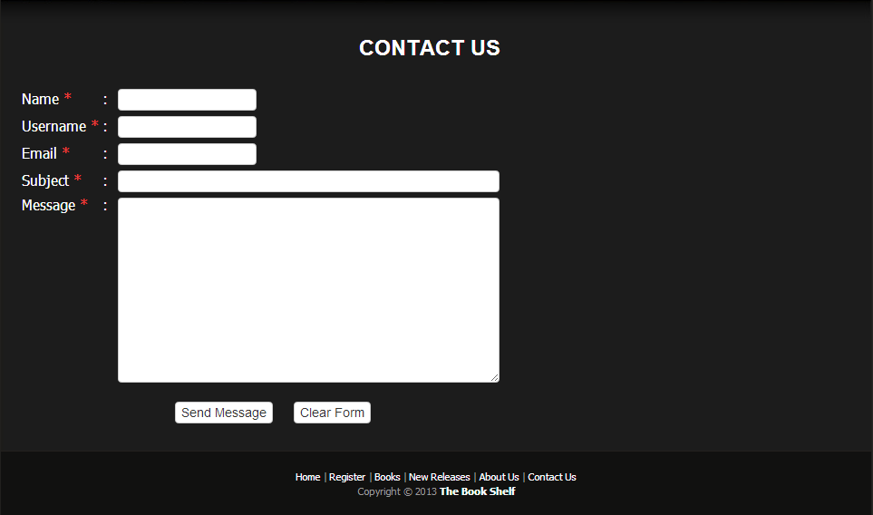

The other Contact Us page, which is “contact2.php”, is created for users to make any enquiries and is explicitly made for users. It differs in the layout – It contains tabs such as, Books, New releases, Your Basket, About Us and Contact on the top, and the categories and bestsellers in the left. This contact form will then be processed by emailsend2.php.

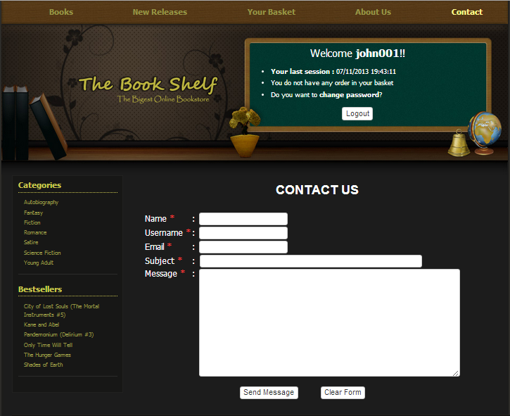

Actually, these two pages have the same function, which is to send an enquiry to the website admin. Those book tab and new book tab can only be seen by a logged in user. Thus, the difference is an unregistered visitor will not be able to access the book and new book pages so that they will have to register and login first before they can start ordering. If an unlogged in user tries to enter the book.php or any other pages which can only be accessible by a logged in user, the PHP file will reject the unlogged in user and direct him/her to the home page.

**3.9 About Us**

The “About Us” button is on the navigation links which can be found on the top of the website. When a user clicks on it, it will direct him/her to the About Us page. Similar to the Contact Us page, there are two About Us pages. One is for users who have logged in and the other one is for any visitor visiting the website. The differences between these two pages are the same as the differences between the two Contact Us pages, e.g. about1.php does not have a list of category and bestselling books on the left side while about2.php has those lists.

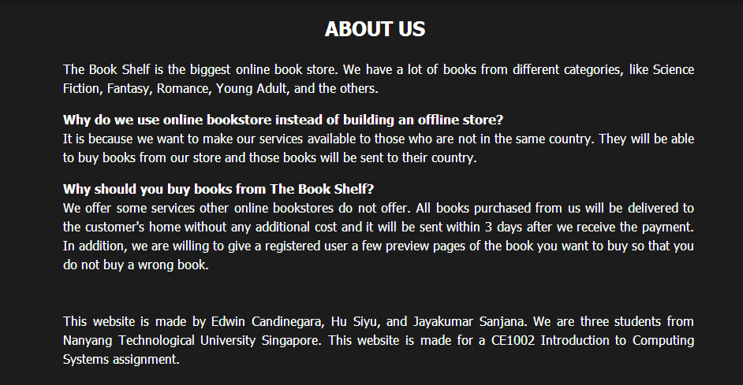

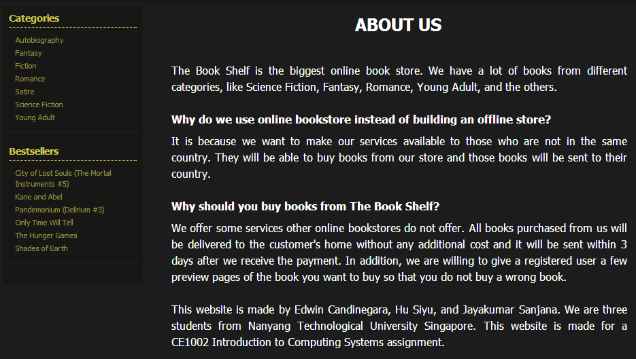

1. **CONCLUSION**

By doing this project, now we are able to implement what we have learned in the lectures and additional lectures. We understand how to make a simple website and how to integrate a website with a database using PHP code. Furthermore, this project pushes us to be more creative since we have to think what kind of features we should put inside the website and also helps us in developing our self-study skills since we still have to look for some syntaxes which are not covered in the lectures or in the additional lectures.